Library Request Form

Dear Librarian, Date: ______________
I would like to request Lexie Nicholas’s books from her Southern Storms series to be added to your library’s collection.
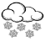
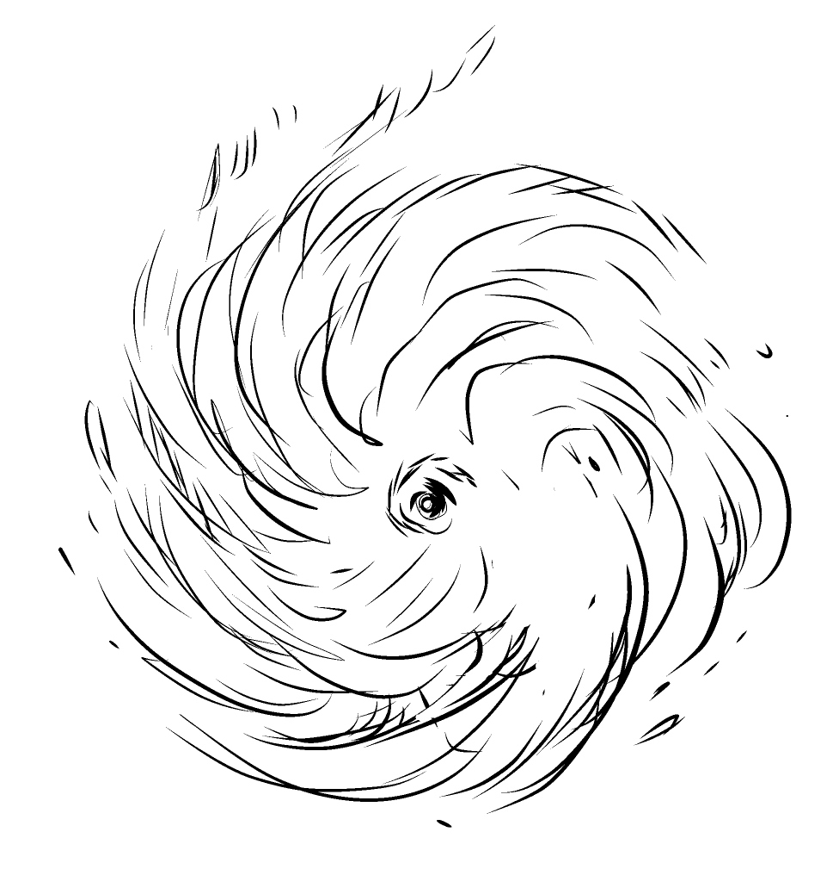
Lexie Nicholas writes clean & wholesome small-town romances set in the South. What sets her books apart is that they feature the excitement of unruly weather that not only complicates the lives of the main characters, it also may be a blessing in disguise.
Here’s what readers say:
“What a cute book! The time they spent in the hurricane was so exciting! I really felt like I was there.” ~ An Amazon Reviewer
“This book is one of the best romance contemporary books I have read in a while. I loved the inclusiveness of this book. We get our main character who has diabetes which is something I have not really seen before.” ~ A Goodreads Reviewer
“This was such a cute book, it ended way to soon but I loved it. I can't wait for another book.” ~ A Goodreads Reviewer
“I absolutely loved this clean Christmas romance. This is the first novel I have read from this author and will be reading more!” ~ An Amazon Reviewer
Could you please add the checked books to your library catalog?
Southern Storms Series by Lexie Nicholas
Title |  | Paperback ISBN  IngramSpark |  | Audiobook ISBN  Overdrive, Hoopla, Bibliotheka etc.
Hurricane Beach |  | 978-1-0879-3889-9 |  | 978-1-6670-7981-3
Twist of Fate |  | 978-1-0879-8220-5 |  | -
Fire Watch |  | 979-8-2016-3024-9 |  | -
Christmas Blizzard |  | 979-8-2155-2703-0 |  | -

Thank you!

____________________________________ _____________________________
Name of Requestor Library Card Number

